To Create Process Escape Sequences, Handle Escaped Spaces, Escape Special Symbols, Preserve Characters, Validate Parser Output, Test Complex Inputs

Code:
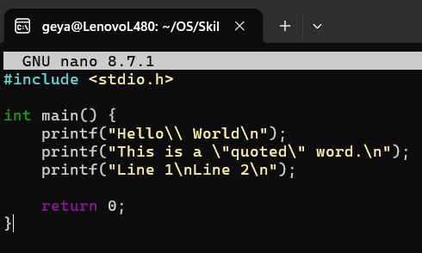

Output:
